**Conceptual Database Design**



**Bright House Apartment**

**Project Phase 2**

**By**

Mr. Anon Kangpanich 6088053

Ms. Tanaporn Rojanaridpiched 6088146

Mr. Tanawin Wichit 6088221

Mr. Pornthep Duangdarw 6088038

A Report Submitted in Partial Fulfillment of

the Requirements for

**ITCS413 - Database Design**

Faculty of Information and Communication Technology

Mahidol University

Semester 2/2019

Table Of Contents

Motivation 0

An Overview Of The Current System 1

Mission Statement 14

Mission Objectives 14

Scope And Boundary 15

Subsystem Definitions 15

• Customer Relationship Management 15

• Customer Lease Management 16

• Customer Payment Management 16

• Room Services 16

• Room Maintenance 16

• Inventory Management 16

• Purchasing Management 17

• Employee Payroll Management 17

• Human Resource Management 17

• Accounting 17

Major User View & Operations 18

**BranchManagement** Users' View 20

**BranchEmployee** Users' View 21

**Customer** Users' View 21

User's Requirement Specifications 21

BranchManagement 21

**Data Requirements** 21

**Transaction Requirements** 24

BranchEmployee 27

**Data Requirements** 27

**Transaction Requirements** 29

Customer 31

**Data Requirements** 31

**Transaction Requirements** 32

System Specifications 32

Initial Database Size 32

Database Rate Of Growth 33

Types And Average Number Of Record Searches 33

Networking And Shared Access Requirements 33

Performance 33

Security 34

Backup And Recovery 34

Legal Issues 34

[Entity-Relationship Diagram 35](https://d.docs.live.net/601873ec7fc0f7d3/Documents/MUICT%20Works/YEAR%203/ITCS413%20-%20Database%20Design/Project%20-%20Bright%20House%20Apartment%20Management%20System/Phase%202/Phase%202%20Report.docx#_Toc33558525)

[Entity Type Specification List 36](https://d.docs.live.net/601873ec7fc0f7d3/Documents/MUICT%20Works/YEAR%203/ITCS413%20-%20Database%20Design/Project%20-%20Bright%20House%20Apartment%20Management%20System/Phase%202/Phase%202%20Report.docx#_Toc33558526)

Relationship Type Association 37

Entity Key List 39

Constraints & Business Rules 42

Constraints 42

Business Rules 46

The User Transaction 48

[User Transactions Pathway Checking 50](https://d.docs.live.net/601873ec7fc0f7d3/Documents/MUICT%20Works/YEAR%203/ITCS413%20-%20Database%20Design/Project%20-%20Bright%20House%20Apartment%20Management%20System/Phase%202/Phase%202%20Report.docx#_Toc33558533)

PHASE 1 CHANGELOG

* Added a description for all subsystems in the scope of the project.
* Created a new form for purchasing order.
* Created a new form for maintenance
* Expanded the scope to cover **Room Maintenance** and **Accounting** as well as **Payroll**
* The word "Supply" and "Inventory" are now related and usually used together.
* **Room Management** and **Booking System** are now merged into **Customer Lease Management**
* **Changes will be highlighted**

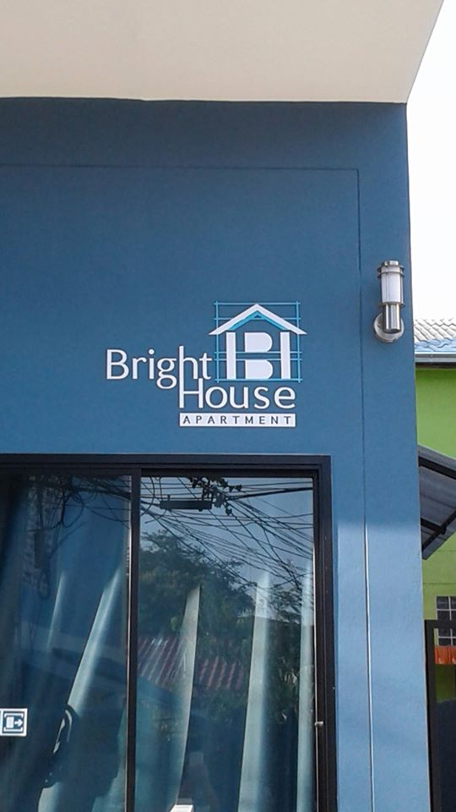**Project Title**: Bright House: Apartment Management System



# Motivation

Bright House apartment is an apartment chain based in Pattaya City, Chonburi, Thailand established in 2017. It has 10 branches scatter throughout Chonburi. Each Branch has 10 - 16 rooms. It offers accommodations at reasonable prices for daily and monthly rental. Most of its customers are foreigners; therefore, additional information such as passport and Visa number has to be kept. Despite its numerous branches, Bright House still using traditional ways of operating. For example, many processes such as accounting, room information, utility tracking, room reservation, and room scheduling are done manually by employees using papers. Thus, during high seasons, front counter employees have to deal with complicated and redundant tasks including searching for available rooms. Moreover, with the director's vision of expanding the business, a database system must be introduced in order to introduce non-existing customer relationship management and mitigate human involvements, which are erroneous. Therefore, a database system must be developed to support the operations of Bright House.

# An Overview of the Current System

A brief description of Bright House's business processes is provided. Bright House is specialized in an apartment for rent especially for foreigners in Pattaya, which is a popular traveler destination, and nearby regions. Bright House currently has 10 branches operated by approximately 80 staff. There are various business processes that require forms and reports.

**Room Schedule 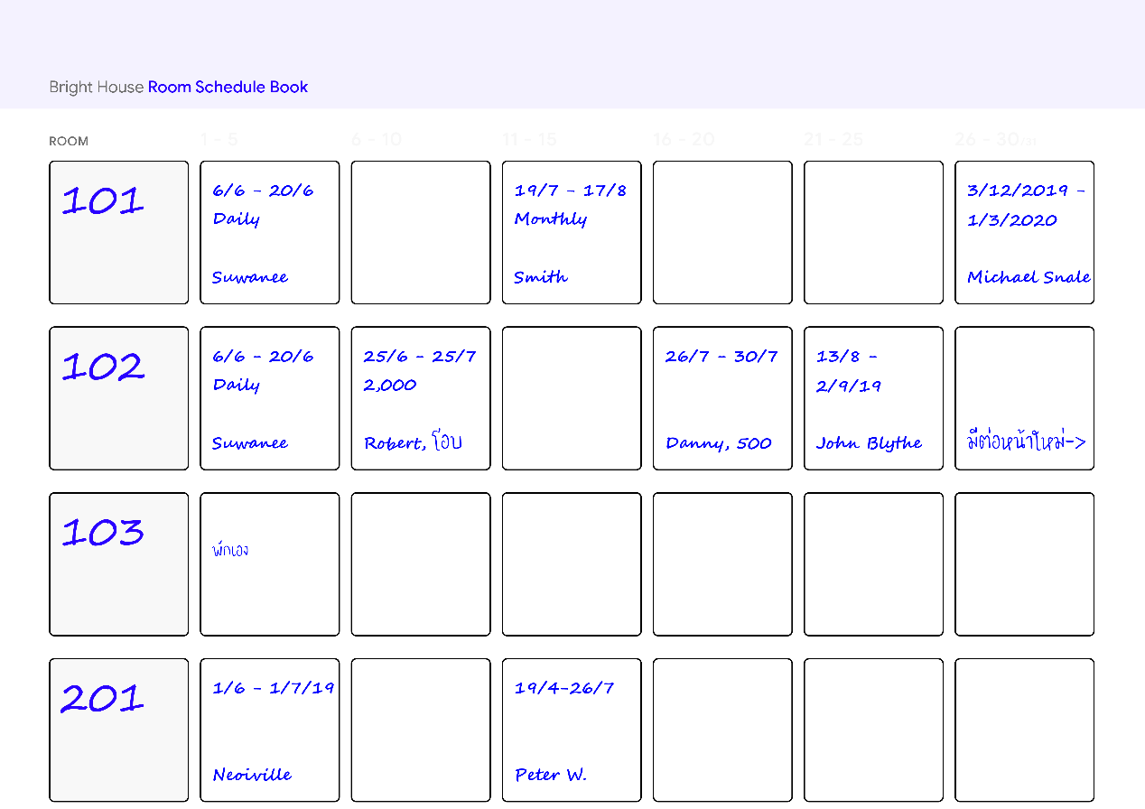Book Page (Form)**

When a customer asked the staff at the counter, in a branch of Bright House, for booking information and available rooms, the staff will look up in the Room Schedule Book which belongs to a branch and includes a representation of a timeline that emphasizes the availability of each room identifiable by using room number. This process usually takes a considerable amount of time as the staff has to skim through several pages. The schedule will be updated when there are new changes to any room. An example of room 101, 102, 103 and 201 **Room Schedule Form** is shown in ***figure 1.***

**Reservation Form**

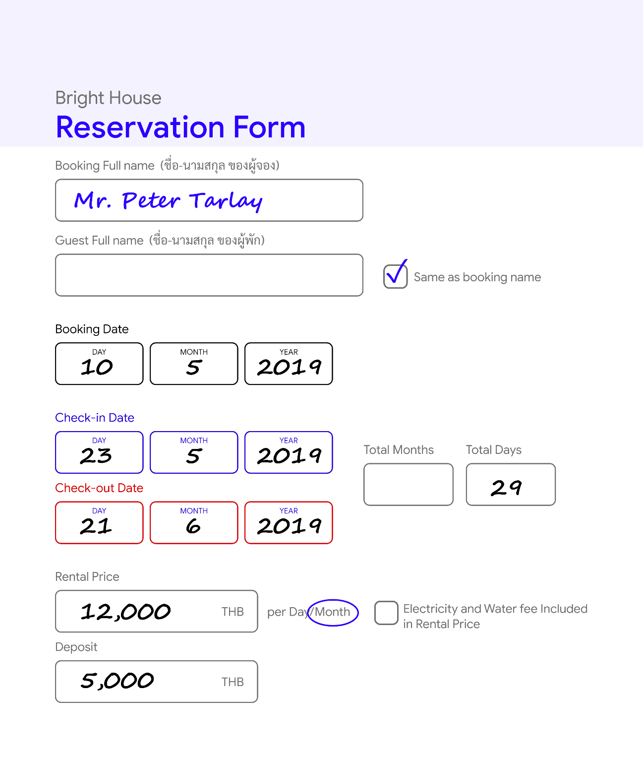

To facilitate customers who want to stay during high seasons, where most rooms are occupied, the reservation form is used to keep track of room availability, a reservation can be made by sending an email, making a phone call or walking into a Bright House branch. When an appointment is made at a counter front or remotely (e.g. phone, email, or social media direct message), the staff will take care of writing the reservation form and update the room schedule. An example of Mr. Peter Tarlay's **Reservation Form** is shown in ***figure 2***.

**Check-in/out Form**

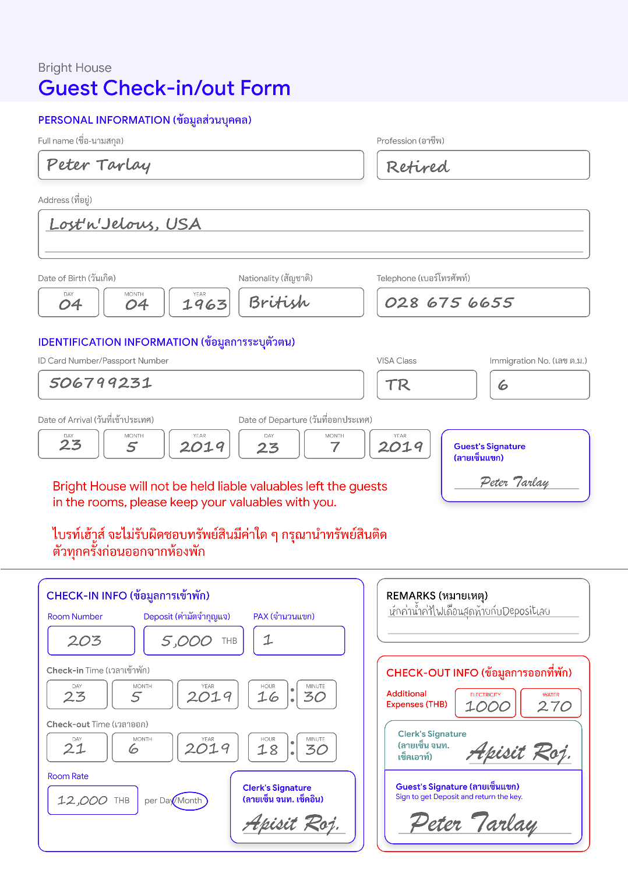

Once a customer desires to book and stay at one of Bright House branches, to keep track of customer information and their stays at Bright House, the staff at the front counter of that branch will prompt the customer to enter their personal information on the Bright House check-in/out form. The form is used will be kept and organized grouped by rooms. Once everything is filled, the staff will verify and shows the customer a room. ***Figure 3*** shows the **Check-in/out form** of Mr. Peter Tarlay.

**Key chain Rental Report**

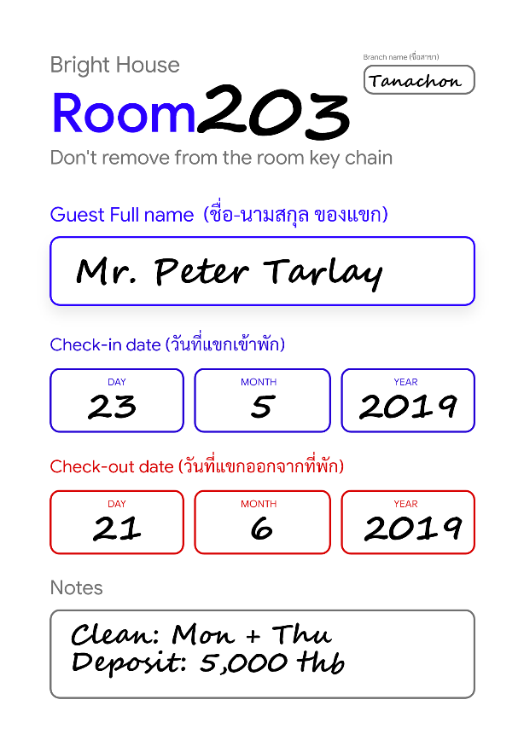To keep track of backup keycards of each occupied room at the counter, the Key Chain Rental Report is attached to each keycard to identify the rent and its customer as well as the room. The backup keycard will be used extensively for cleaning services. ***Figure 4*** shows an example of a room 203 **Key Chain Rental Report**.

**Room Supply List (Form)**

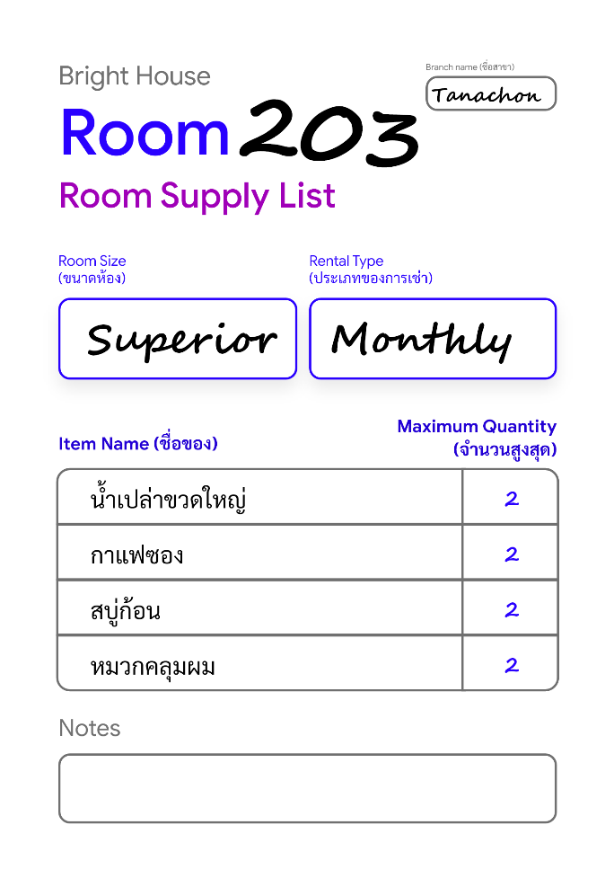To keep track of the maximum amount of room supplies to give, the Room Supply List will be given to each room for employees to check and refill those supplies to a specified amount depends on the rental type. If the rental type is monthly, then room supplies will be provided at the start of the rental once. If the rental type is daily, then room supplies will be provided daily, Furthermore, the maximum amounts of supply are varied based on customer requests, the rental type and the rental period of a stay. When a customer request is given, the staff will jot down the description of the request onto the supply list and determine the total amount of supplies that needed to be provided. ***Figure 5*** shows the **Room Supply List Form** for room number 203.

**Monthly Room Cleaning Check List (Form)**

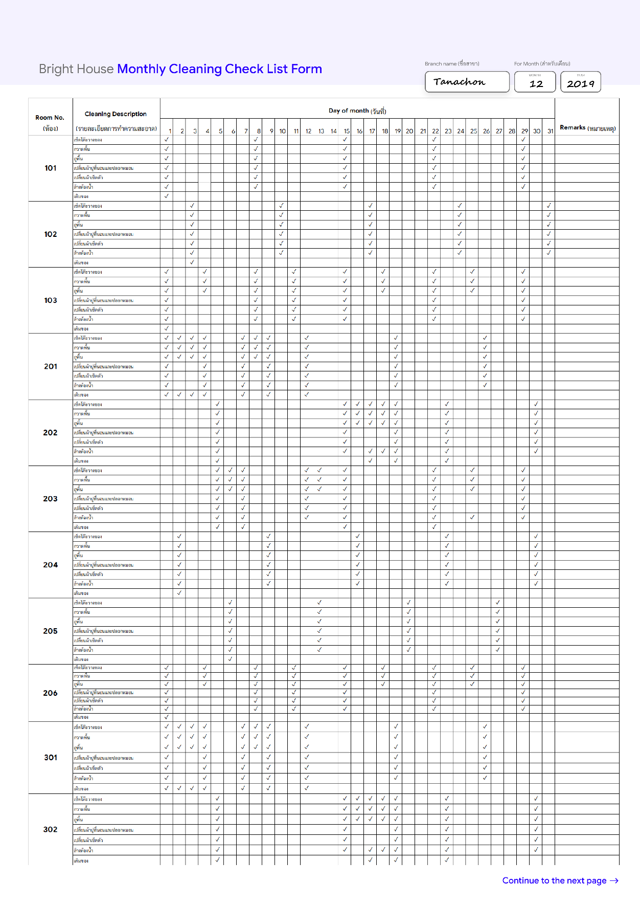

To keep track of room cleaning service over a month, the Monthly Room Cleaning Check List is used as a form for cleaning staff to track, schedule and record their service which consists of multiple subtasks. An example of the **Cleaning Check List** for December 2019 is illustrated in ***figure 6***.

**Branch Supply Stock List (Report)**

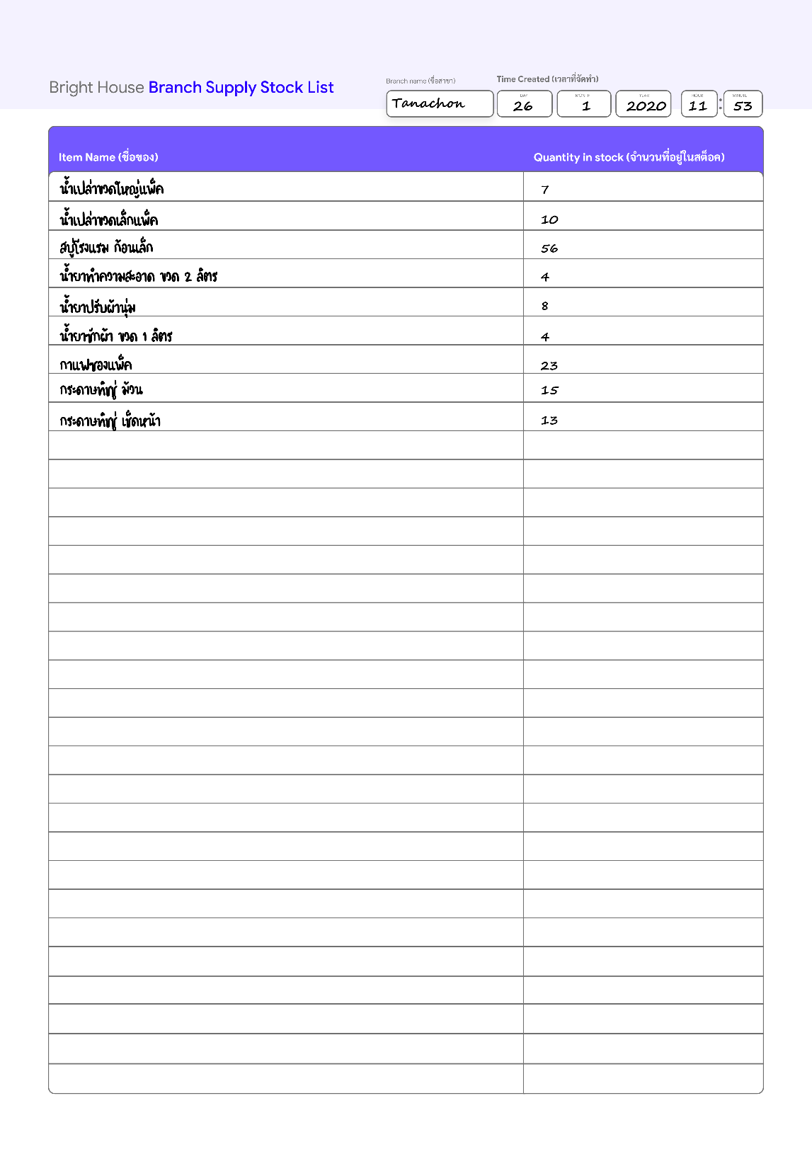

Once a Bright House branch needs to restock their supply inventory, a Branch Supply Stock List is generated to be used to decide which items to resupply. ***Figure 7*** shows the Stock List generated on 26 January 2020.

**Room Utility Report Form**

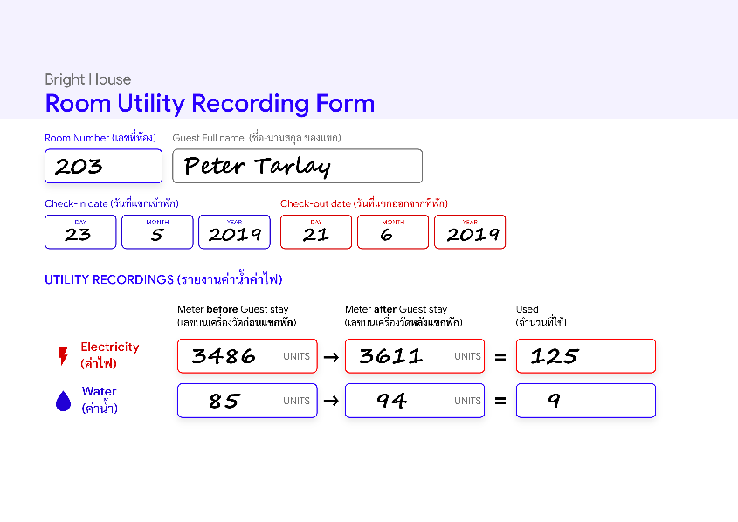To calculate the utility costs and charge customers in the month, in each monthly stay, the total amount of water and electricity utilities that can be read from meters of a room will be recorded in units by an employee using the Room Utility Report Form as shown in ***figure 8*** which illustrates an example for room 203.

**Room Utility Summary**

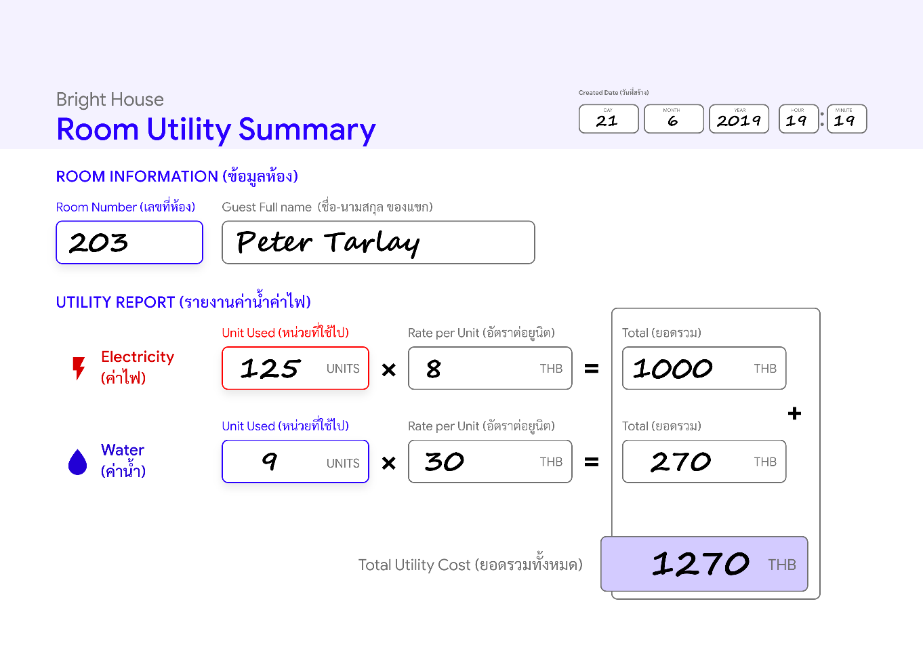

In order to charge monthly-stay customers for electricity and water cost, both costs must be calculated by multiplying the total unit used and the price per unit and recorded to the Room Utility Summary as illustrated in ***figure 9***. The monthly-stay customer will have to pay the utility every month as long as the duration of their stay.

**Occupied Room List (Report)**

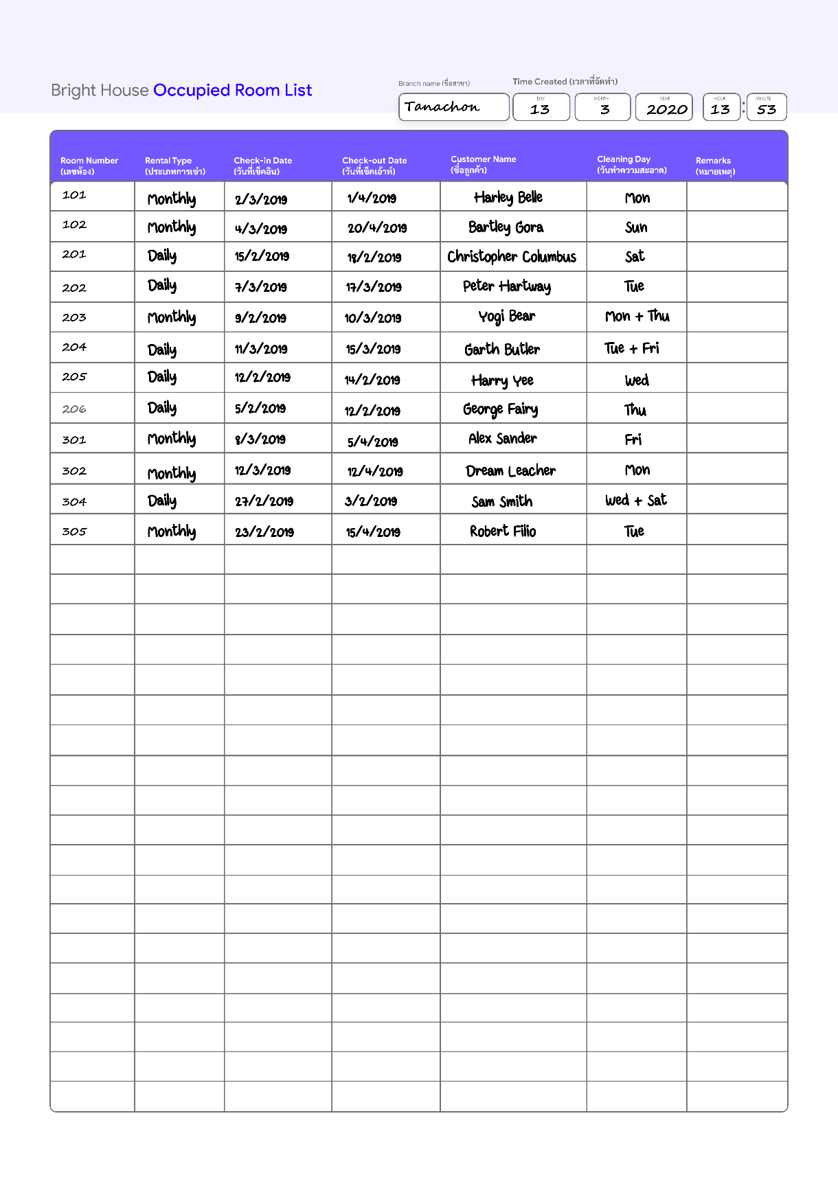

In order to make keeping track of guests in a branch easier, the occupied room list is used. Cleaning personnel, security, a branch manager could use this report to adjust their services efficiently. As shown in ***figure 10,*** the **list of the occupied rooms** of the branch Tanachon is illustrated.

**Payment Bill (Report)**

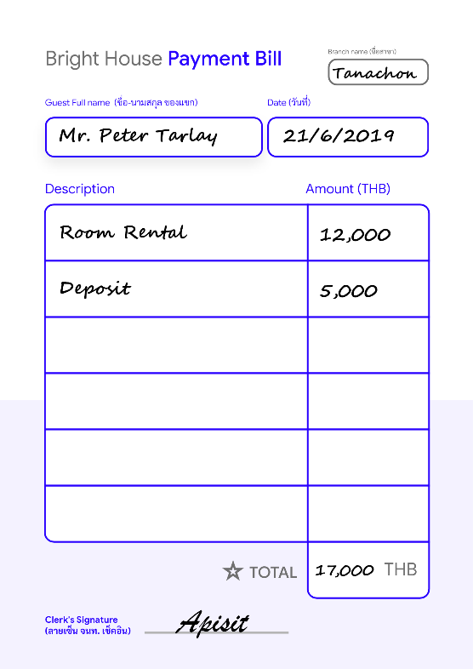To provide evidence of customer payment, a payment bill is written every time the customer checks in and the bill will be completed when the rental fee is paid at the counter in the branch that they stay. Moreover, the deposit will also be returned to the customer. A **payment bill** is also created when other types of transactions are made. For example, a customer requests extra cleaning services, or purchase bottles of fresh water, etc. ***Figure 11*** illustrates a payment bill for Mr. Peter's rental. Please note that utility costs will not be recorded inside the bill because they will be charged monthly separately by using the **Room Utility Summary** report.

**Employee Application Form**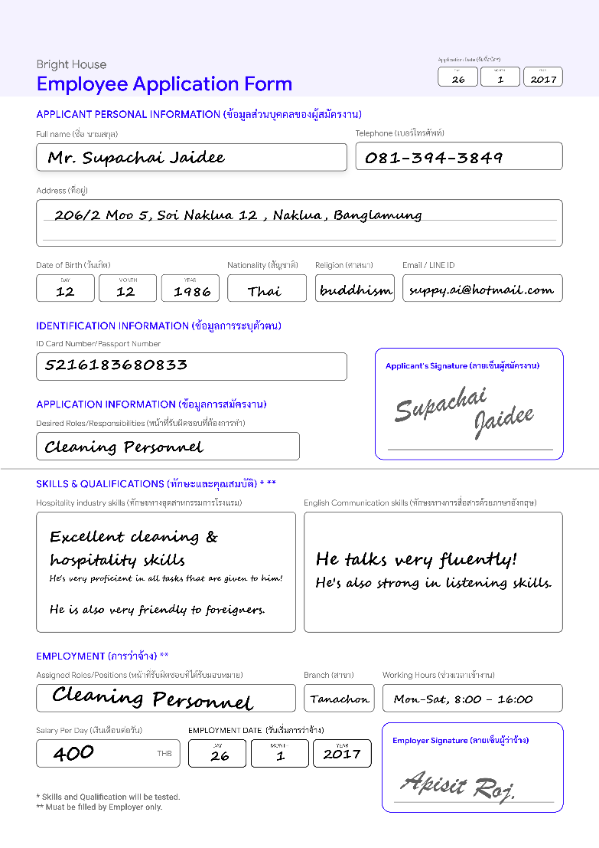

To facilitate servicing, payroll, branch stock tracking, and accounting, when a job applicant applies for a job at Bright House, the applicant must write their information to the registration form. Later the applicant will be tested in various hospitality skills. Each applicant can have multiple tasks given by the branch manager. Moreover, application date, work experience, and English skills will also be recorded as well. ***Figure 12*** shows Mr. Supachai Jaidee's **application form**.

**Branch Employee Listing (Report)**

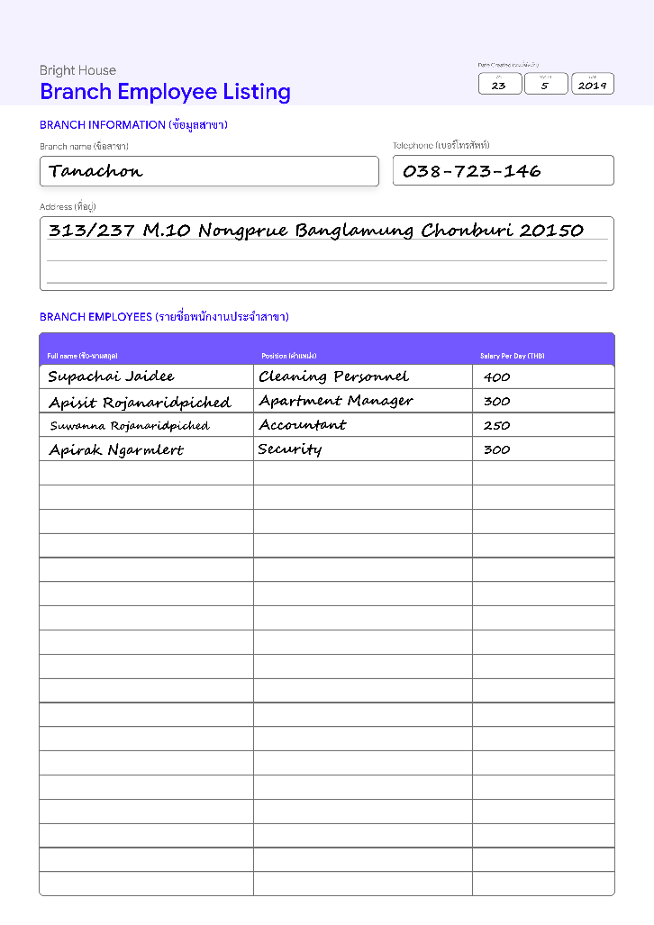To help a branch manager in managing employees, a branch employee list is used to shows the name, position, and daily salary for all employees as shown in ***figure 13***.

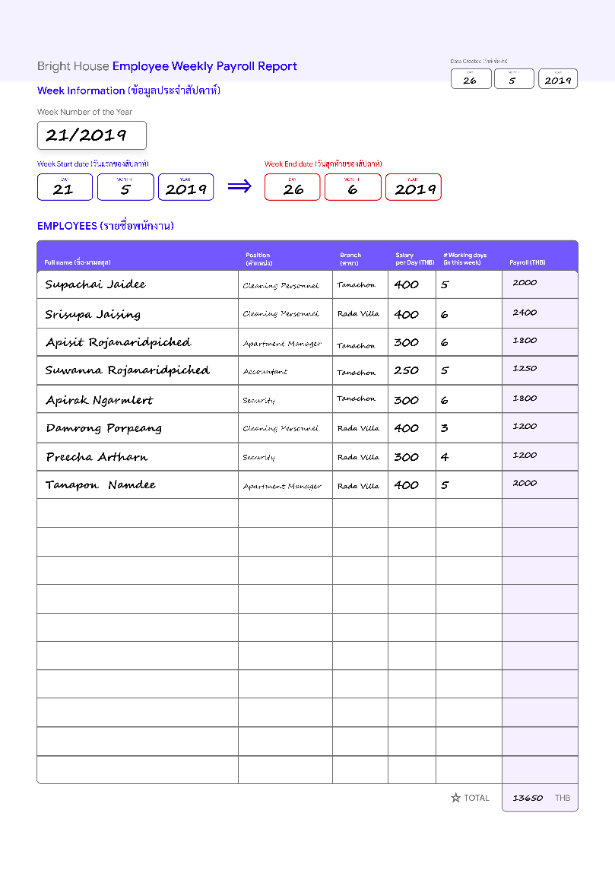

**Employee Weekly Payroll Report**

Typically, Work attendance and work hours will be kept for every employee every week. Later the branch manager will payroll their employees depends on their work hours over the week and performances. To facilitate the payroll process, an employee Weekly Payroll Report, as shown in ***figure 14***, must be created before any payroll transaction could happen.

**Ledger (Form)**

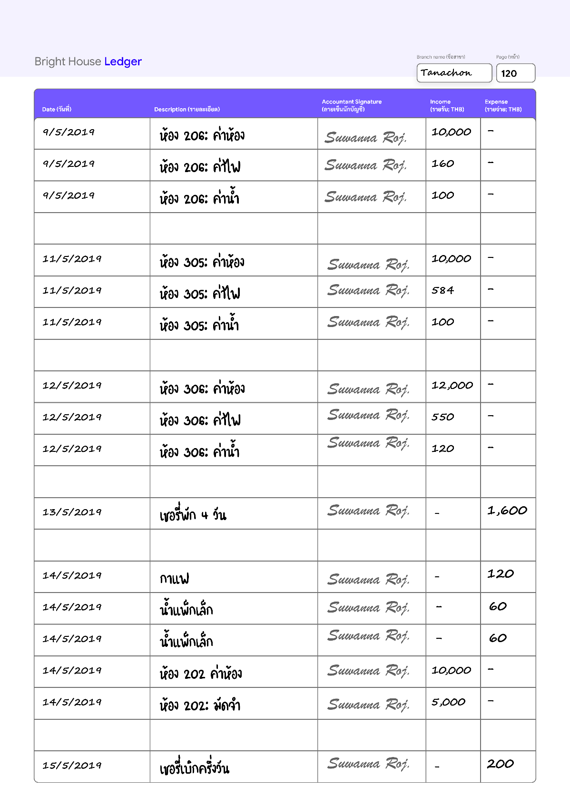

Similar to most businesses, to record every financial transaction related to Bright House, each branch will have its own **financial Ledger**, as shown in ***figure 15***, managed by a branch manager, that records incomes and expenses in day-by-day operations.

**Branch Supply Tracker (Form)**

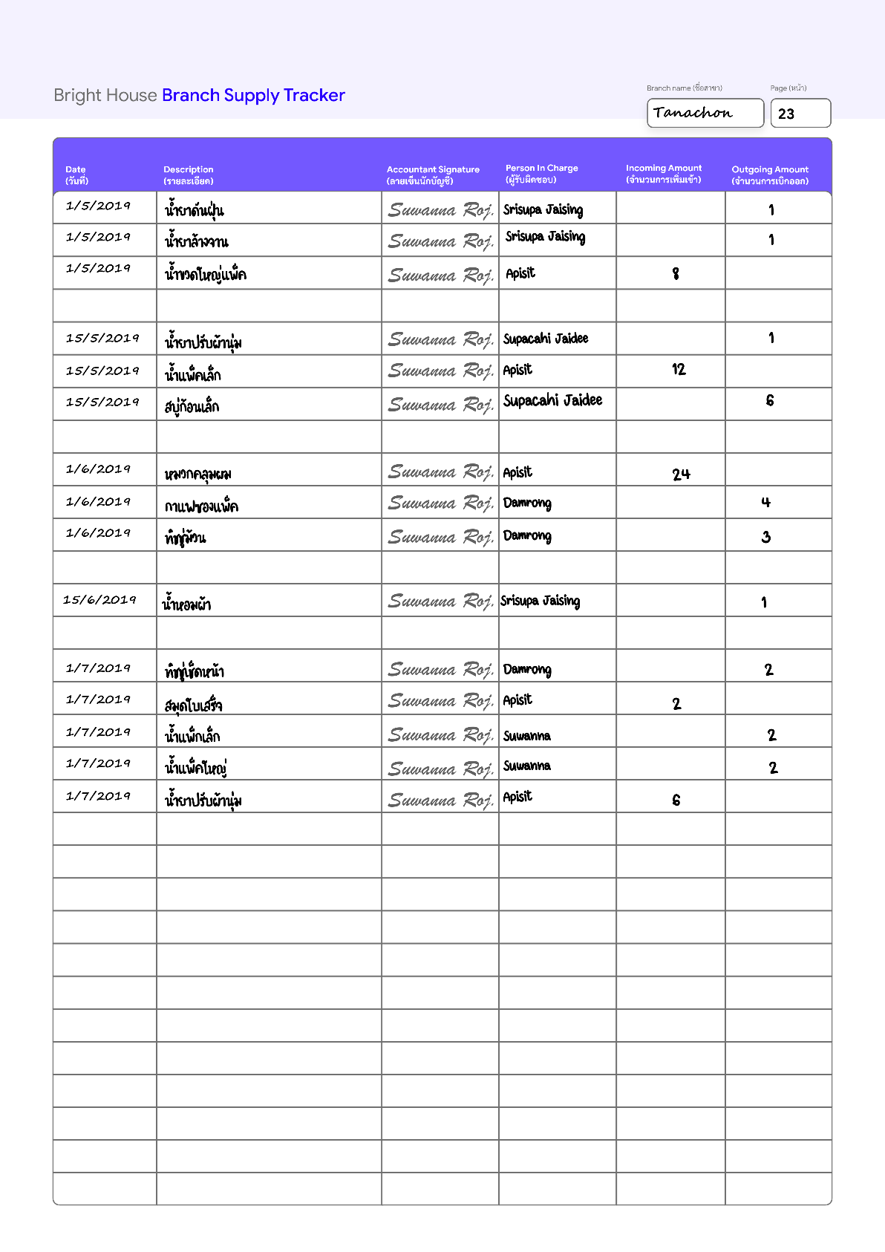

In order to monitor transactions of supply inventory with efficiency and transparency in each branch, Branch Supply Tracker is used as a form by a branch accountant. ***Figure 16*** shows **the supply tracker** used by Tanachon Branch.

**Customer Feedback Form**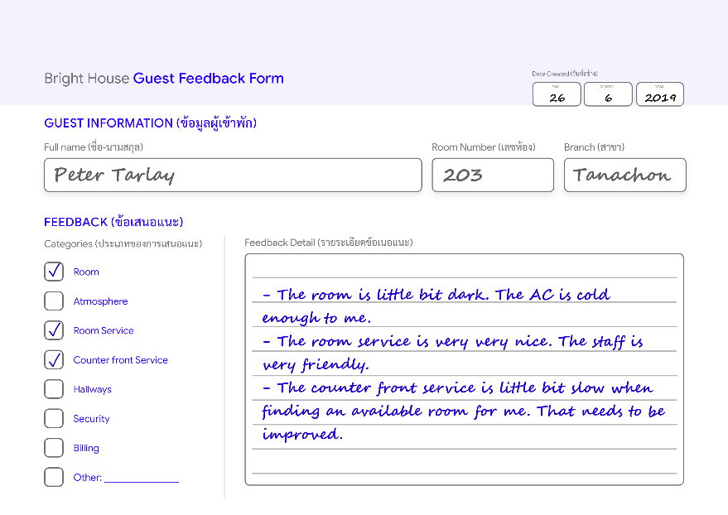

To improve overall services, all guests can give their feedback during or after each rental. All feedback will be kept by a branch manager for further improving processes. ***Figure 17*** shows Mr. Peter Tarlay **feedback**form after his rental ends***.***

**Purchasing Form**

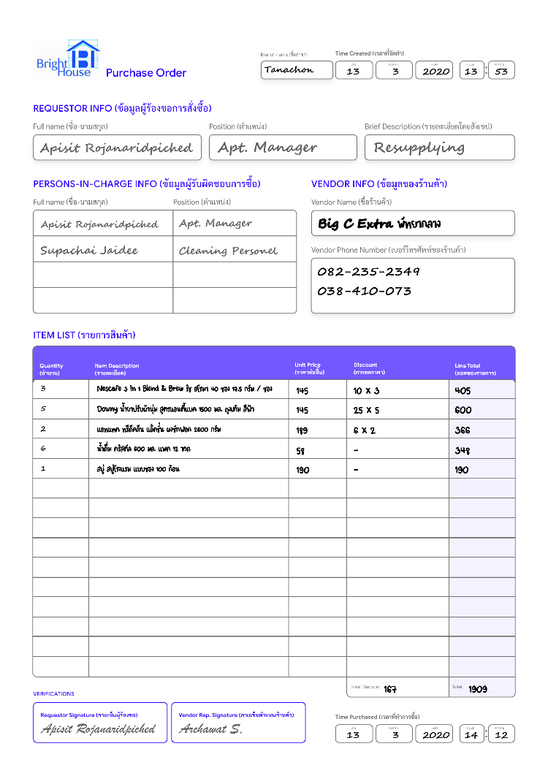When a branch manager requires its employees to resupply a branch inventory, a purchasing form will be issued by the branch manager. Products to be bought are listed by the manager. The branch manager will assign employees that are in charge of the purchasing. If the branch manager does not select any specific vendor, the ones in charge can select any vendor. After products are checkout, the ones in charge have to record the price and discount of each product into the form as well as ask a vendor employee to sign their signature to verify their acknowledgment. ***Figure 18*** shows Mr. Apisit, a branch manager, requests 5 products to be bought using **the purchasing form**.

**Maintenance Form**

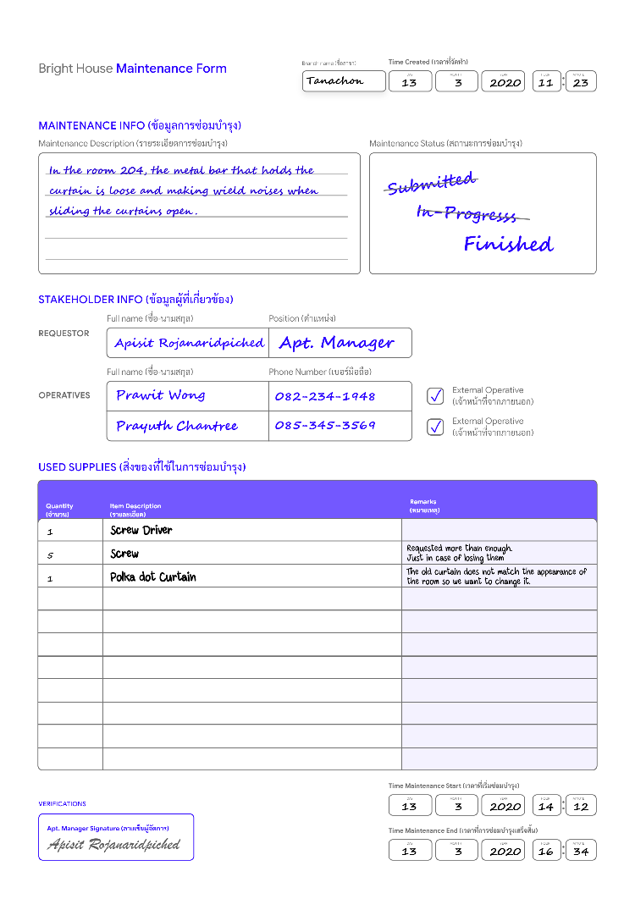When damage to the property of an apartment is discovered, a maintenance form will be written by an employee who discovers it. The form will be reviewed by the branch manager. If the damage needs to be mitigated, the branch manager will assign the ones in charge. Ones in charge can be an employee of any position, who is capable of repairing, or external personnel such as repairman. In some instances, supply, such as screwdriver, screws, are required for maintenance; thus, they are listed on the form. ***Figure 19*** shows a **maintenance form** for repairing a curtain rail requested by Mr. Apisit.

# Mission Statement

The purpose of the **Bright House database system** is to manage, organize and secure all operational data that facilitates unified efficient high-quality service and resource management through minimized data redundancy and consistency.

# Mission Objectives

The Mission Objectives for the **Bright House database system** are specified as follows:

* To manipulate (insert/update/delete) data of apartment rooms, room supply services, employees, rentals, customers, room utility, payment, supply inventory, maintenance, payrolls, and purchasing.
* To facilitate various time-consuming processes such as room assigning and room scheduling.
* To enable detailed customer data and feedback data capture that can facilitate customer relationship management.
* To report on branches, employees, rooms, room servicing, supplies, rents, customers, expenses from supply inventory, maintenance, payrolls, and purchasing check-in, and check-out instances.
* To perform searches on branches, employees, rooms, room servicing, supply inventory, maintenance, payroll, purchasing, rents, customers, expenses from payrolls, purchasing, check-in, and check-out instances.

# Scope and Boundary

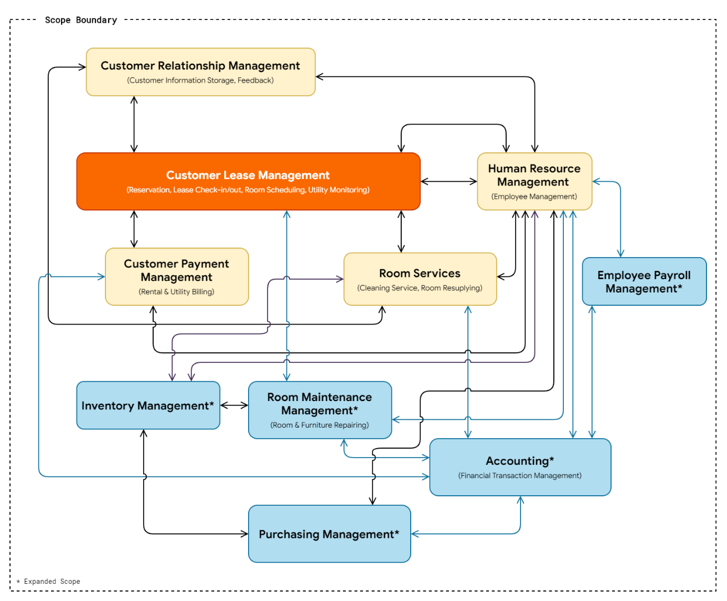

## Subsystem Definitions

### Customer Relationship Management

The subsystem is responsible for the storage of customer information and customer feedback that facilitates personalization by using historical data to communicate with old customers in order to retain and gain loyalty to generate more income as well as improving overall services via feedback collection.

### Customer Lease Management

**Customer Lease Management system** manages rentals and reservations that are made by customers. It also specifies rental prices associated with the room size and rental type (e.g. monthly or daily rent). It also deals with room utility monitoring to facilitate in billings of monthly rents. Furthermore, the system also facilitates faster counter-front service by providing a counter officer (a branch manager) a way to search for an appropriate room that does not conflict with other reservations or rental.

### Customer Payment Management

The **payment system** supports the process of persisting customers for their rental fees, additional room services, and property damage penalty fee.

### Room Services

The **room service** subsystem is responsible for the persistent and scheduling room service routine, which includes periodic room cleaning and room resupplying.

### Room Maintenance

The **room maintenance system** enables each branch to monitor and persist maintenance tasks performed on apartment properties (such as furniture and decorations) as well as monitor resources that are being used to carry out each maintenance.

### Inventory Management

The **inventory management system** enables each branch to monitor the direction of how branch-owned properties are being used. Branch-owned properties or items can be categorized into 3 groups:

1. **Consumable supply that does not required to be returned** such as rolls of tissue paper.
2. **Consumable supply that can be returned to the inventory** such as sticky tapes and floor wax.
3. **Non-consumable items** such as furniture and decorations.

### Purchasing Management

The **purchasing management system** persists vendor information and purchasing orders made by branch managers. It works in conjunction with the accounting system.

### Employee Payroll Management

The **employee payroll system** works in conjunction with the Human Resource Management system and accounts system in the sense that it gets the number of working hours of employees and calculate total payroll and makes a transaction record in the accounting system.

### Human Resource Management

The **Human Resource management system** is the main system in the sense that it interacts with most subsystems and is responsible for the storage of employee information, salary, working hour, daily tasks, job application information, and job position.

### Accounting

The **accounting system** acts as central storage for all financial transactions made internally for all customer payments, payrolls, and purchasing.

# Major User View & Operations

| **Data** | **Access Type** | **Owner** | **Apartment Manager** | **Accountant** | **Cleaning Personnel** | **Security** | **Customer** |
| --- | --- | --- | --- | --- | --- | --- | --- |
| All Branches | Maintain |  |  |  |  |  |  |
| Query | **✓** | **✓** |  |  |  |  |
| Report | **✓** | **✓** |  |  |  | **✓** |
| Single Branch | Maintain |  | **✓** |  |  |  |  |
| Query |  | **✓** |  |  |  |  |
| Report |  | **✓** |  |  |  |  |
| All Employees | Maintain |  |  |  |  |  |  |
| Query | **✓** | **✓** |  |  |  |  |
| Report | **✓** | **✓** |  |  |  |  |
| Branch Employee | Maintain |  | **✓** |  |  |  |  |
| Query |  | **✓** |  |  |  |  |
| Report |  | **✓** | **✓** | **✓** | **✓** |  |
| All Customers | Maintain |  |  |  |  |  |  |
| Query | **✓** | **✓** |  |  |  |  |
| Report | **✓** |  |  |  |  |  |
| Branch Customer | Maintain |  | **✓** |  |  |  |  |
| Query |  | **✓** |  |  |  |  |
| Report |  | **✓** |  |  |  |  |
| **All Supply Inventory** | Maintain |  |  |  |  |  |  |
| Query | **✓** |  |  |  |  |  |
| Report | **✓** | **✓** | **✓** |  |  |  |
| **Branch Supply Inventory** | Maintain |  |  | **✓** |  |  |  |
| Query |  | **✓** | **✓** |  |  |  |
| Report |  | **✓** | **✓** | **✓** |  |  |
| All Room Services | Maintain |  |  |  |  |  |  |
| Query | **✓** |  |  |  |  |  |
| Report | **✓** |  |  |  |  |  |
| Branch Room Service | Maintain |  |  |  | **✓** |  |  |
| Query |  | **✓** |  | **✓** |  |  |
| Report |  | **✓** |  | **✓** |  |  |
| All Rooms | Maintain |  |  |  |  |  |  |
| Query | **✓** |  |  |  |  |  |
| Report | **✓** | **✓** |  |  |  |  |
| Branch Room | Maintain |  | **✓** |  |  |  |  |
| Query |  | **✓** |  | **✓** | **✓** |  |
| Report |  | **✓** |  | **✓** | **✓** | **✓** |
| All Customer Payments | Maintain |  |  |  |  |  |  |
| Query | **✓** |  |  |  |  |  |
| Report | **✓** | **✓** | **✓** |  |  |  |
| Branch Customer Payment | Maintain |  | **✓** |  |  |  |  |
| Query |  | **✓** | **✓** |  |  |  |
| Report |  | **✓** | **✓** |  |  |  |
| All Room Utilities | Maintain |  |  |  |  |  |  |
| Query | **✓** |  |  |  |  |  |
| Report | **✓** | **✓** | **✓** |  |  |  |
| Branch Room Utility | Maintain |  | **✓** |  |  |  |  |
| Query |  | **✓** | **✓** |  |  |  |
| Report |  | **✓** | **✓** |  |  |  |
| All Reservations | Maintain |  |  |  |  |  |  |
| Query | **✓** | **✓** |  |  |  |  |
| Report | **✓** |  |  |  |  |  |
| Branch Reservation | Maintain |  | **✓** |  |  |  |  |
| Query |  | **✓** |  |  |  |  |
| Report |  | **✓** | **✓** | **✓** | **✓** | **✓** |
| All Rentals | Maintain |  |  |  |  |  |  |
| Query | **✓** | **✓** |  |  |  |  |
| Report | **✓** | **✓** |  |  |  |  |
| Branch Rental | Maintain |  | **✓** |  |  |  |  |
| Query |  | **✓** |  |  |  |  |
| Report |  | **✓** |  | **✓** | **✓** |  |
| **All Payrolls** | Maintain |  |  |  |  |  |  |
| Query | **✓** |  |  |  |  |  |
| Report | **✓** | **✓** | **✓** |  |  |  |
| **Branch Payroll** | Maintain |  | **✓** |  |  |  |  |
| Query |  | **✓** | **✓** |  |  |  |
| Report |  | **✓** | **✓** | **✓** | **✓** |  |
| **All Financial Transaction** | Maintain |  |  |  |  |  |  |
| Query | **✓** |  |  |  |  |  |
| Report | **✓** | **✓** | **✓** |  |  |  |
| **Branch Financial Transaction** | Maintain |  |  | **✓** |  |  |  |
| Query |  | **✓** | **✓** |  |  |  |
| Report |  | **✓** | **✓** |  |  |  |
| **All Maintenance** | Maintain |  |  |  |  |  |  |
| Query | **✓** |  |  |  |  |  |
| Report | **✓** | **✓** | **✓** |  |  |  |
| **Branch Maintenance** | Maintain |  | **✓** |  |  |  |  |
| Query |  | **✓** | **✓** |  |  |  |
| Report |  | **✓** | **✓** | **✓** | **✓** |  |
| **All Purchasing** | Maintain |  |  |  |  |  |  |
| Query | **✓** |  |  |  |  |  |
| Report | **✓** | **✓** |  |  |  |  |
| **Branch Purchasing** | Maintain |  | **✓** | **✓** |  |  |  |
| Query |  | **✓** | **✓** |  |  |  |
| Report |  | **✓** | **✓** | **✓** | **✓** |  |

***Figure 17*** is the result ofan analysis of major user views with respects to the data requirements of each position as well as the basic data operations: maintain, query and report. The main types of data used by each user's view are illustrated in a simpler a cross-reference table as illustrated in ***table 1***.

|  |  |  |  |  |  |  |
| --- | --- | --- | --- | --- | --- | --- |
| **Data** | **Director** | **Apartment Manager** | **Accountant** | **Cleaning Personnel** | **Security** | **Customer** |
| Branch | **✓** | **✓** |  |  |  | **✓** |
| Employee | **✓** | **✓** | **✓** | **✓** | **✓** |  |
| Customer | **✓** | **✓** | **✓** | **✓** | **✓** |  |
| Supply Inventory | **✓** | **✓** | **✓** | **✓** |  |  |
| Room Service | **✓** | **✓** |  | **✓** |  |  |
| Room | **✓** | **✓** |  | **✓** | **✓** | **✓** |
| Customer Payment | **✓** | **✓** | **✓** |  |  |  |
| Room Utility | **✓** | **✓** | **✓** |  |  |  |
| Reservation | **✓** | **✓** | **✓** | **✓** | **✓** | **✓** |
| Rental | **✓** | **✓** |  | **✓** | **✓** |  |
| Financial Transaction | **✓** | **✓** | **✓** |  |  |  |
| Payroll | **✓** | **✓** | **✓** | **✓** | **✓** |  |
| Maintenance | **✓** | **✓** | **✓** | **✓** | **✓** |  |
| Purchasing | **✓** | **✓** | **✓** | **✓** | **✓** |  |

According to ***table 1***, it can be observed that the Director and Branch Manager completely share the same data access characteristic; thus, both of them are merged into a group of **BranchManagement**. Furthermore, since the accountant, cleaning personnel and security share similarities in data access and requirements. They also are the positions that bound to only a branch; therefore, the name of **BranchEmployee** is given to the group. Lastly, customers also have their own Customer Users' Views because of their unique data requirements.

### **BranchManagement** Users' View

* **Director** responsible for making the overall business decisions; therefore, extensively relevant summary reports are mandatory.
* **Branch Manager** is considered to be a receptionist at a branch responsible for managing room reservations, payments, rentals, payments, etc. Moreover, a branch manager will also be the one who carries out Customer Relationship management.

### **BranchEmployee** Users' View

* An **accountant** is responsible for managing a branch's supplies, incomes, and expenses.
* **Cleaning Personnel** responsible for room resupplying and cleaning services. Cleaning personnel can withdraw supplies via an accountant directly.
* **Security** is responsible for the overall security of an apartment branch. They are allowed to access information that can be helpful while in duty. That information includes branch employees, room information, and customer rental.

### **Customer** Users' View

* A **Customer** has access to gain knowledge, that helps to generate awareness of the business, room availability, branches as well as reservations using Bright House's public online channels. A customer can also keep track of the feedback that they submitted.

# User's Requirement Specifications

## BranchManagement

### **DATA REQUIREMENTS**

#### BRANCH

Bright House apartment has multiple branches scattered throughout the eastern region of Thailand. Each branch is managed by has employees which also include the branch manager who responsible for the daily operation of the business. The description of branch data includes the manager name, full branch name, up to 3 telephone numbers, address, fax number, email address, opening hours, and date of establishment. Additionally, the date that the manager gets his or her position at the current branch is also recorded.

#### EMPLOYEE

As a manager, the employee data is used to consider when an employee applies for a job. Moreover, it is also used to estimate the salary of employees. Employees must provide Citizen ID Number, First name, Last name, Phone numbers, Nationality, and Work experience. Additionally, gender, work position, and associated branch number.

#### CUSTOMER

To facilitate the growth of the business by using customer relationship management, Bright House will emphasize on unifying customer information between branches to create a seamless data boundary between branches. All personal information given by the customers will be stored in terms of first name, middle name, last name, nationality, identification number or passport number, date of birth, contacts such as emails, Facebook account, and telephone numbers. As well as individual customer feedback that is also important for business growth. After receiving customer feedback, a branch manager will keep a record of those.

#### SUPPLY INVENTORY

Each supply that belongs to each branch must be recorded by a branch accountant to increase the transparency of inventory in every branch; therefore, item name, item type, time of the stock transaction as well as the quantity and transaction types (e.g. incoming, outgoing) must be stored. Additionally, for each record, the name of the person in charge and another one, who oversees the transaction, is also required and will also be recorded as well.

#### ROOM SERVICE

To ensure that the service will cover every customer in each branch and facilitate the scheduling of works, each record of room service will have the timestamp of service request creation, the status of the service (e.g. scheduled, in-progress, finished), the target room number, the name of the cleaner, the time that the service is finished, the type of the service and the subtasks will also be recorded.

#### ROOM

Since each branch manager has to take care of all the rooms in the apartment, room information should be exposed and consist of the room number, room size, furniture list, room supply list, and location (e.g. branch, building, floor number). Room numbers are not unique across all branches.

#### CUSTOMER PAYMENT

To enable a systematic way to generate financial reports, any customer payment such as utility payment, rental payment or extra cleaning service payment will be recorded in terms of the transaction time, the amount, the name of the customer and the money receiver name.

#### ROOM UTILITY

Since utility must be manually kept tracked for each room, before any rental, a branch manager must record the room's water and electricity initial unit when customer check-in and the final amount unit when customer check-out to calculate the total utility cost. Time Recorded, the room number, the rental number, the number of units of electricity, and the number of units of water will be recorded.

#### RESERVATION

When a customer sends a reservation message to a branch manager, the manager should keep important information such as customer name, the time which the reservation starts, duration of the reservation, room number, the name of a responsible employee, the time which the reservation is created, and special request note. There is no limit on the number of reservable rooms.

#### RENTAL

To secure customer rental data, rental number, rental time, rental duration, rental ending time, rental fee, rental room number, the branch, rental customer name, additional remark and rental type (e.g. daily or monthly) are required and need to be recorded to facilitate in the process of generating useful reports. Please note the rental number is unique across all branches.

#### PAYROLL

Since employees are the main driver of the business, integrating payroll into the system could enable transparency to all employees. For each employee, starting time and ending time for each working day will be recorded. Thus, when it is for employees to obtain a salary, total working hours will be calculated individually to finally calculate the actual salary. Each employee can query and get a report of their payrolls to ensure transparency.

#### FINANCIAL TRANSACTION

Since there are transactions from customers (from room rental, extra room services, and property damage fine), purchasing, and payrolls, the financial transaction system must integrate every money transfer similar to the financial ledger. Accountants can also review each financial transaction to ensure financial integrity.

#### MAINTENANCE

Since occurrences of property damage are not rare, all maintenance should be recorded in terms of description, starting time, ending time, status, and category of maintenance. This also helps branch managers to keep track of maintenance that sometimes take a long time to complete. Please note that some time property damage is caused by customers. If the damage done is severe, they will be charged additionally.

#### PURCHASING

In order for a branch to operate normally, it relies on externals products such as washing powder, floor wax, etc.; as a consequence, purchasing becomes a regular task. Each instance of purchasing will be recorded in terms of vendor, status, type, created time, approval time, rejected time. The level of details of each purchasing will be each purchasing line which includes only one product or supply. Before any purchase can take place, it must be approved by either a branch manager or an accountant.

### **TRANSACTION REQUIREMENTS**

#### DATA ENTRY

1. Enter the details of a new **Branch** (such as branch ID 1; "Tanachon", manager ID 1, ...).
2. Enter the details of a new Member of an **Employee** at a branch (such as Supachai Jaidee).
3. Enter the details of a new **Customer** who check-in for the first time at the front counter at a branch. (such as Peter Tarlay).
4. Enter the details of a new **Room** in a Branch (such as room number 203 is a superior room, which consists of a bed, a television, a wardrobe, and a safe, located on the 2nd floor at Tanachon branch).
5. Enter the details of new **Customer Payment** (such as payment for room number 203 rented by Peter Tarley).
6. Enter the details of a new **Room Utility** record (such as an electricity utility record of room number 203 on 23/5/2019 is 3486 units).
7. Enter the details of a new **Reservation** record received from a customer email or phone call (such as a reservation record for Peter Tarlay booked on 10/5/2019).
8. Enter the details of a new **Rental** at a branch (such as customer Peter Tarlay is renting and staying at room number 203 at Tanachon branch as a monthly rental started 23/05/2019).
9. Enter the details of a new employee work attendance for the calculation of **Payroll** at a branch (For example, Mr. Supachai Jaidee comes to work at the Tanachon branch at 07:00, and leaves the work at 21:00).
10. Enter the details of a new **Maintenance** instance that occurred within a branch in terms of maintenance description, requestor name and position. Furthermore, start and ending time, operatives who carry out the maintenance and supply used will also be recorded.
11. Enter the details of a new **Purchasing** requested by anyone who is a branch employee. Requestor information, a brief description, person-in-charge list, vendor info and item list (only item description and unit price are required) must be specified.

#### DATA UPDATE/DELETION

1. Update/delete the details of a **Branch.**
2. Update/delete the details of a member of **Employee** at a branch.
3. Update/delete the details of a **Customer** including feedback**.**
4. Update/delete the details of a **Room** in a Branch.
5. Update/delete the details of a given **Customer Payment** at a given branch.
6. Update/delete the details of a **Room Utility** at a given branch.
7. Update/delete the details of a room **Reservation** made by a customer **at a given branch.**
8. Update/delete the details of a room **Rental** at a given branch.
9. Update/delete the details of a **Payroll of** a given employee **at a given branch.**
10. Update/delete the details of a **Maintenance** at a given branch. An update will occur when there is a change in maintenance status.
11. Update/delete the details of a **Purchasing** at a given branch. An update of a purchasing will happen after the person-in-charge has proceeded to purchase the items. An update will include time purchased, discounts, and unit price (if any).

#### DATA QUERIES

1. List the details of **branches** in a given area of the Eastern region of Thailand.
2. List all details of **employees** given an employee ID, name, surname, or branch name.
3. Identify the total number of **employees** in all branches.
4. Identify the average salary of **employees** in each position, gender, branch, ordered in ascending order.
5. List all active branch **managers** ordered by the branch address.
6. List **employee** details by a given position, name, ID, and Date of birth.
7. Identify the total **employee** payroll for a day, week or month.
8. Identify the total number of unique **customers** that have ever visited at least one branch.
9. List unique **customers** that have ever visited at least one branch.
10. Identify the average age of **customers** from each nationality.
11. List **customer** details grouped by a given branch.
12. List **customer** details by a given duration from their last visited time ordered by the duration.
13. List details of **customers** who recently stay more than one branch of Bright House ordered by descending order.
14. List details of **supplies** that are used the most by any branches.
15. Identify the average number of **supplies** left at the end of every week grouped by each the name of the supply.
16. List room details with a status of the **rental** by a given branch or area.
17. List all **rooms** that currently have guests staying grouped by room size.
18. List the details of customer **payment transactions** along with full customer name and nationality that has the top-10-most transaction amounts in a given month.
19. Identify the average **customer** **payment** amount grouped by transaction type.
20. Identify the average amount of money in **customer payments** grouped by customer's nationality, and ordered by month.
21. Identify the **customer payment** that has the highest amount of money grouped by month, customer's nationality.
22. List the **customer payment** by a given rental number and customer name.
23. Identify the average amount of **customer** **payments** grouped by month.
24. Identify the frequency of **rental** grouped by month.
25. List all **rentals** that will be **expired** within a given time range at a branch.
26. List all **rooms** that will be **free** within a given time range at any branch in a case the customer must be redirected to another branch.
27. List all **rentals** in any branches associated with a given **customer**.
28. List all **room services** done to a specified **room** within a branch.
29. List all **room services** done to a specified **rental** within a branch.
30. Identify the average duration of **customer rentals** within any branch.
31. Identify the average duration of stay of all **customer** Visa within any branch.
32. List all **branches** ordered by the total number of free rooms within a given time range.
33. Identify **months** that have a high amount of reservations.
34. Identify **months** that have a high amount of income.
35. Identify the difference between income from rentals & additional cleaning services and expenses from room supply during high and low seasons.
36. List **feedback** reported by **customers** categorized by branches.
37. Identified the total number of customer **feedback** in each branch.
38. Identified the total number of customer **feedback** grouped by categories.
39. Identified the average number of customer **feedback** per rental.
40. List customer **feedback** from all branches in a given period of time.
41. List all **payrolls** made within a given period of time.
42. List all **employees** that has total **payroll** within a given threshold range.
43. Identify the average of employee **payrolls** in a given time range.
44. List all **maintenance** instances of a branch based on a given maintenance status.
45. For each branch, list all supplies used in all **maintenance** so far.
46. List all **external operatives** that involved in any **maintenance** instance.
47. List all completed **maintenance** instances that took more than a given time duration to complete.
48. List all on-going **maintenance** instances that take more than a given time duration so far.
49. List all on-going **purchasing** instance and its items.
50. Identify the average of a given item out of all **purchasing** instances that contain it.
51. Identify the total sum of money used in **purchasing** instances within a given time range.
52. List all **items** that is included in any **purchasing** instances in a given time range.

## BranchEmployee

### **DATA REQUIREMENTS**

#### EMPLOYEE

The data required on employees include employee number, name, surname, citizen ID, date of birth, address, position, gender, phone number. Each employee will have their own position, but they can have more than 1 phone number.

#### CUSTOMER

For the employee, they will need to retrieve some of the customer data including the customer's name and surname, and phone number for the cleaning personnel since they may need to make an appointment with customers.

#### SUPPLY INVENTORY

The accountant of each branch is also responsible for verifying supply transfer that is being withdrawn or deposit from the inventory. Since cleaning personnel is the one who responsible for refilling customers' rooms with supplies on requests of customer requests or routines, information on branch inventory is needed to be exposed to employees.

#### ROOM SERVICE

To improve customer experience and hygiene inside a room, each rental will come with a cleaning service that will be scheduled based on intervals. There are 2 types of room services: cleaning and supplying. Cleaning service has multiple subtasks all of which will be done by cleaning personnel. The subtasks include wiping the table, sweep the floor, mop the floor, clean the bathroom, change towels, change sheets and pillowcases. Each cleaning personnel has the ability to keep track of their processes. Lastly, the customer can request for additional room services at a price.

#### ROOM

Every employee needs to know room data. However, each position needs a different set of data. For instance, the Accountant needs to know room number, room size, furniture list, room supply list, while cleaning personnel need to know the building, room number, furniture list, room supply list. As for security, they only need to know about Building, floor number, room number.

#### CUSTOMER PAYMENT

All customer payments will be monitored by a branch accountant. All branch accountants can verify customer transactions to ensure the transparency of all transactions within their respective branches.

#### ROOM UTILITY

The cost of the utility of each room is exposed to a branch accountant for the creation of monthly financial reports. An accountant is also allowed to query utility data for the use of verifying the branch financial ledger.

#### RESERVATION

Some reservation information is exposed to the branch accountant, cleaning personal and security in order to help in various processes such as cleaning and security scheduling as well as income and expense estimations.

#### PAYROLL

An accountant is only allowed to inspect the payroll records by querying and report. While employees in another position allowed to inspect payroll records but only limited to payrolls that belongs to the individual employee.

#### FINANCIAL TRANSACTION

An accountant is the only position that is allowed to manipulate the financial transaction in a branch. Financial transactions can be either customer rental transactions, payroll transactions, property damage fine, or purchasing. It is used as a financial ledger for the branch.

#### MAINTENANCE

Any employee that is not a branch manager is allowed to request the branch manager for maintenance. They can get involved in maintenance operations. When maintenance status needs to be updated, operatives cannot do so directly, but instead, they have to inform the manager. Furthermore, the maintenance can also get queried by any employee.

#### PURCHASING

Besides a branch manager, an accountant is also allowed to manipulate purchasing instance with a branch. While other employee positions are allowed to get a report of branch purchasing. Similar to maintenance, if an employee desire to make a purchase, it must be approved by either a branch manager or an accountant before the purchase happens.

### **TRANSACTION REQUIREMENTS**

#### DATA ENTRY

* Enter the data of a **Room Service** (such as room 203 with the superior room size and being rent monthly will receive "น้ำเปล่าขวดใหญ่", "กาแฟซอง", "สบู่ก้อน", "หมวกคลุมผม". Each with a quantity of 2).
* Enter the details of a new transaction of **Supply** (such as "น้ำเปล่าขวดใหญ่แพ็ค" is being transferred into Tanachon Branch with the quantity of 10 pcs. by Supachai Jaidee).
* For accountants, Enter the details of a new **Financial Transaction** made from either customer rental transactions, payroll transactions, property damage fine, or purchasing.
* For accountants, Enter the details of a new **Purchasing** requested any employees likewise to what a branch manager can.

#### DATA UPDATE/DELETION

* Update/delete the details of a **Room Utility** at a given branch.
* Update/delete the details of a **Customer Payment** at a given branch.
* Update/delete the details of a **Room** at a given branch.
* Update/delete the details of a **Supply** at a given branch.
* Update/delete the details of a **Room Service** at a given branch.
* Update/delete the details of a **Financial Transaction** specific to a branch. An update of a purchasing will happen after an accountant reviewed a transaction and flagged it as reviewed.
* Update/delete the details of a **Purchasing** at a given branch. An update of a purchasing will happen after the person-in-charge has proceeded to purchase the items. An update will include time purchased, discounts, and unit price (if any).

#### DATA QUERIES

1. List the number, full name, working hours, position of **Employees** by a given branch sorted by name alphabetically.
2. List the details of **Supplies** by a given branch and supply name, ordered by quantity in ascending order.
3. List details of **supplies** that are used the most by a branch.
4. List the details of **Room Services** for cleaning personnel.
5. List the number, floor, and building of **Rooms** that have occupied by customers.
6. Identify the total sum of **Customer** **Payment** within a given period in a branch.
7. Identify the **Room Utility** cost for a monthly rental within a branch.
8. Identify the total **Room Utility** cost for all monthly rentals within a branch.
9. List all **Utility** records of a given Room and given rental number.
10. List the room number, check-in time, check-out time and type of **Rental** for the process of planning and scheduling room services and security routine.
11. List **Customer** **Payments,** that associates with a branch, by time and transaction type.
12. List room number, customer name, rental type, deposit, rental amount, as well as **supplied** used by the **room**.
13. List all **rentals** that will be **expired** within a given time range at a branch.
14. List all **rooms** that will be **free** within a given time range at any branch in a case the customer must be redirected to another branch.
15. Identify room number and rental type of branch **reservations** that are scheduled within a given time range.
16. List all **room services** done to a specified **room** within a branch.
17. List all **room services** done to a specified **rental** within a branch.
18. List all **room services** done by a given **employee** in a branch.
19. List all **rental check-in** that is supervised by a given **employee**.
20. List all **rental check-out** that is supervised by a given **employee**.
21. List periods that have the maximum number of cleaning service requests within a branch ordered by descending order.
22. Identify the average number of unique **customers** per week within a branch in a given time range.
23. Identify the average number of new **customers** per week within a branch in a given time range.
24. Identify which **room** has the longest rental duration from any customer with a given period.
25. Identify which periods will have the highest **utility** usages in terms of unit or cost in a branch.
26. List items to be purchased in a given on-going **purchasing** instances.
27. List **maintenance** instances within a given time range.
28. List **financial transaction** made in a branch with a given period of time.
29. List **payrolls** that are associated with a given employee.
30. Identify the total sum of money in all payrolls that associated with a given **employee**.

## Customer

### **DATA REQUIREMENTS**

#### BRANCH

A customer has access to the basic information of branches such as the branch's name, location, office working hours, room capacity, telephone numbers, fax number, and email address.

#### ROOM

Customers can access the total number and details of available rooms in order to select the room for booking or reservation. Moreover, customers should know room size, floor number, the building number are of which can affect room prices.

#### RESERVATION

A customer will be the person who provides reservation information. They should be able to access the data about their booking.

### **TRANSACTION REQUIREMENTS**

#### DATA ENTRY

Customer does not enter the data by themselves. It is the duty of a branch manager.

#### DATA UPDATE/DELETION

Customer does not update/delete the data by themselves. It is the duty of a branch manager.

#### DATA QUERIES

1. List the details of **Rooms** in each branch.
2. List the details of a **Reservation** that a particular customer has reserved. (A customer can reserve a room and get the details of the Reservation that they have made)
3. List the details of **Branches** by a location given by a customer.
4. List the details of **Available rooms** in each branch.
5. List the **Contact** details in each branch.
6. List the **Feedback** that is submitted by the customer who gave the feedback.

# System Specifications

## Initial Database Size

* There are approximately 80 members of staff working in 10 branches. There is an average of 8 staff at each branch.
* There are approximately 134 rooms in all branches. Each branch has more than 10 rooms and a maximum of 15 rooms.
* There are approximately 220 customers for all branches in 1 day. Each branch has about 22 customers in 1 day.
* There are approximately 20 reservations for all branches in 1 day. Each branch has about 2 reservations in 1 day.
* There is approximately 30 payment transaction for all branches in 1 week. Each branch has about 3 payments in 1 week.
* There are approximately 500 supplies for all branches. Each branch has about 50 supplies.
* There are approximately 100 financial transactions for all branches in a week. Each branch has approximately 20 transactions in a week.

## Database rate of growth

* Approximately 50 new customers will be added to the database across all branches each month. If customers did not rent the room from the last time within two years, the record will be deleted.
* Approximately 300 new rentals will be added to the database across all branches each month. The record will be deleted after 2 years after the creation of the record.
* Approximately 10 new employees join and leave the company each month. The data of employees will be deleted after 1 year after the employee leaves the apartment.

## Types and average number of record searches

* Search for detail of branch - approximately 10 per day.
* Search for detail of room - approximately 50 per day (during low season), approximately 400 per day (during high season).
* Search for an employee in each branch - approximately 20 per day.
* Search for detail of customers - approximately 20 per day.
* Search for detail of rental - approximately 100 per day.

## Networking and shared access requirements

All branches should be securely networked to a centralized database located at Bright House's main office in Soi Buakhao. The system should allow for 1 to 2 people concurrently accessing the system from each branch.

## Performance

* During opening hours, but not during peak periods, expect less than a 1-second response for all single record searches. During peak periods, expect less than a 3-second response for each search.
* During opening hours, but not during peak periods, expect less than a 3-second response for each multiple record searches. During peak periods, expect less than a 5-second response for each search.
* During opening hours, but not during peak periods, expect less than a 1-second response for all single record each update/save. During peak periods, expect less than a 3-second response for each update/save.

## Security

* The database should be password-protected.
* Each member of staff should be assigned database access privileges appropriate to a particular user view.
* A member of staff should see only the data necessary to do his or her job in a form that suits what he or she is doing.
* A client should see only their own booking data and personnel details using the Bright House apartment website.

## Backup and recovery

The database should be backed up daily at 6 a.m. Since Pattaya is a night tourist city, most people do not sleep at night. They will sleep in the morning. People also wake up late so most people begin their daily life at noon.

## Legal issues

Bright House database holds data from staff and clients. Data privacy is a personal data must be kept legally. Legal issues must be complied with should be investigated and implemented.

# Entity-Relationship Diagram

# Entity type specification list

# Relationship Type Association

| **Entity** | **Multiplicity** | **Relationship** | **Multiplicity** | **Entity** |
| --- | --- | --- | --- | --- |
| Customer | 1..1 | Gives | 0..* | Feedback |
| Customer | 0..1 | Makes | 0..* | Reservation |
| Customer | 0..* | Requests | 0..* | RequestedRoomService |
| Customer | 0..1 | Responsible for | 1..1 | CustomerBilling |
| Customer | 1..1 | Books | 0..* | Rental |
| CustomerRoomService | 0..* | Involves | 1..1 | Rental |
| CustomerRoomService | 0..* | Consists of | 1..* | RoomServiceAction |
| PropertyInspection | 1..1 | Discovers | 0..* | PropertyDamage |
| PropertyInspection | 0..1 | Involves | 1..1 | Room |
| PropertyInspection | 1..1 | Involves | 1..1 | Rental |
| PropertyDamage | 1..1 | Leads to | 0..1 | CustomerBillingLine |
| PropertyDamage | 0..* | Done to | 1..1 | RoomObject |
| PropertyDamage | 0..1 | Causes | 0..1 | Maintenance |
| CustomerBilling | 0..1 | Causes | 1..1 | FinancialTransaction |
| CustomerBilling | 1..1 | Has | 1..* | CustomerBillingLine |
| RentalPeriod | 0..1 | Leads to | 1..1 | CustomerBillingLine |
| Rental | 1..1 | Consists of | 1..* | RentalPeriod |
| Rental | 0..* | Consists of | 1..* | Customer |
| Rental | 0..* | Has | 1..1 | Room |
| Rental | 1..1 | Consists of | 1..* | CustomerBilling |
| Reservation | 0..1 | Leads to | 0..* | Rental |
| Reservation | 0..* | Mentions | 1..* | Room |
| RoomUtilityRecord | 2..2 | Used for a calculation of | 0..2 | UtilityCost |
| UtilityCost | 0..1 | Leads to | 1..1 | CustomerBilling |
| RentalPeriod | 1..1 | Ties to | 0..1 | UtilityCost |
| Maintenance | 1..* | Has | 0..* | ExternalOperative |
| Maintenance | 0..* | Requires | 0..* | Supply |
| 0..* | Requires | 0..* | InventoryEntry |
| RoomObject | 0..* | Need | 0..* | Maintenance |
| Room | 1..1 | Has | 1..* | RoomUtilityRecord |
| Room | 1..1 | Has | 0..* | RoomObject |
| Branch | 1..1 | Manages | 1..* | Reservation |
| Branch | 1..1 | Has | 1..* | Employee |
| Branch | 1..1 | Has | 0..* | InventoryEntry |
| Branch | 1..1 | Has | 1..* | Room |
| Branch | 1..1 | Manages | 0..* | Rental |
| Employee | 1..1 | Carries out | 0..* | CustomerRoomService |
| Employee | 0..* | Take an action based on | 0..* | Feedback |
| Employee | 0..1 | Reviews | 0..* | Feedback |
| Manager | 1..1 | Manages | 1..* | Reservation |
| Employee | 1..1 | Creates | 1..* | RoomUtilityRecord |
| Manager | 1..1 | Creates | 0..* | CustomerBillingLine |
| Manager | 1..1 | Manages | 0..1 | Branch |
| Employee | 1..* | Carries out | 0..* | Maintenance |
| Employee | 1..* | Records | 0..* | InventoryEntry |
| Accountant | 1..1 | Oversees | 0..* | InventoryEntry |
| Employee | 1..1 | Requests | 0..* | Purchasing |
| Employee | 1..* | Takes parts in | 0..* | Purchasing |
| Employee | 1..1 | Records | 0..* | Vendor |
| Manager | 1..1 | Approves | 0..* | Maintenance |
| Manager | 0..1 | Approves | 0..* | Purchasing |
| Accountant | 1..1 | Reviews | 0..* | FinancialTransaction |
| Accountant | 0..1 | Approves | 0..* | Purchasing |
| Manager | 1..1 | Pay | 1..* | Employee |
| 1..1 | Involves in | 1..* | FinancialTransaction |
| Employee | 1..* | Involves in | 1..* | FinancialTransaction |
| Branch | 1..1 | Has | 1..* | Employee |
| InventoryEntry | 0..* | Involves | 1..* | RoomObject |
| InventoryEntry | 0..* | Involves | 1..1 | Supply |
| Vendor | 1..1 | Involves | 1..* | Purchasing |
| CleaningPersonnel | 1..1 | Carries out | 0..* | CustomerRoomService |
| Cleaning | 1..1 | Uses | 0..* | ReturningSupply |
| AddingSupply | 1..1 | Uses | 0..* | Supply |
| RequestRoomService | 0..1 | Leads to | 1..1 | CustomerBillingLine |
| ReturningDeposit | 0..* | Involves | 1..1 | ReturningSupply |
| PurchasingSupply | 1..1 | Leads to | 1..1 | PurchasingDeposit |
| Purchasing | 1..1 | Cover | 1..* | PurchasingLine |
| Purchasing | 1..1 | Causes | 0..1 | FianacialTransaction |
| PurchasingLine | 1..* | Has | 0..1 | Supply |
| PurchasingLine | 1..1 | Has | 0..1 | RoomObject |
| CustomerRoomService | 0..1 | Requires | 0..* | InventoryEntry |
| RoomObjectModel | 1..1 | Has | 1..* | RoomObject |
| Employee | 1..1 | Requests | 0..* | Maintenance |

# Data Dictionary

The list of attributes associated with each entity and relationship.

# Entity Key List

Candidate, the primary and the alternate keys for each entity are as follows:

| **Entity Name** | **Candidate key** | **Alternate key** | **Primary key** |
| --- | --- | --- | --- |
| **Accountant** |  |  |  |
| **AddingSupply** |  |  |  |
| **Branch** | branchNum |  | BranchNum |
| **Cleaning** |  |  |  |
| **CleaningPersonnel** |  |  |  |
| **Customer** | customerNum |  | customerNum |
| citizenId | citizenId |  |
| **CustomerBilling** | billingNumber |  | billingNumber |
| **CustomerBillingLine** |  |  |  |
| **CustomerRoomService** | serviceNumber |  | serviceNumber |
| **Employee** | employeeNum |  | employeeNum |
| firstName, lastName | firstName, lastName |  |
| firstName, lastNam, dob | firstName, lastNam, dob |  |
| **ExternalOperative** |  |  |  |
| **Feedback** | feedbackNumber |  | feedbackNumber |
| **FinancialTransaction** | financialTransactionNumber |  | financialTransactionNumber |
| **InventoryEntry** | entryNumber |  | entryNumber |
| **Maintenance** | maintenanceNumber |  | maintenanceNumber |
| **Manager** |  |  |  |
| **PropertyDamage** | propertyDamageNumber |  | propertyDamageNumber |
| **PropertyInspection** | propertyInspectionNumber |  | propertyInspectionNumber |
| **Purchasing** | purchasingNumber |  | purchasingNumber |
| **PurchasingDeposit** |  |  |  |
| **PurchasingLine** |  |  |  |
| **Rental** | rentalNumber |  | rentalNumber |
| **RentalPeriod** |  |  |  |
| **RequestedRoomService** |  |  |  |
| **Reservation** | reservationNumber |  | reservationNumber |
| **ReturningDeposit** |  |  |  |
| **ReturningSupply** |  |  |  |
| **Room** | roomNumber | roomNumber |  |
| roomNumber, floor | roomNumber, floor |  |
| **RoomObject** | objectNumber |  | objectNumber |
| **RoomObjectModel** | objectModelId |  | objectModelId |
| objectModelId, objectModelCategory | objectModelId, objectModelCategory |  |
| objectModelId, objectModelBarCode, objectModelCategory | objectModelId, objectModelBarCode, objectModelCategory |  |
| **RoomServiceAction** | roomServiceNumber |  | roomServiceNumber |
| **RoomUtilityRecord** | roomUtilNumber |  | roomUtilNumber |
| **RoutineRoomService** |  |  |  |
| **Supply** | supplyNumber |  | supplyNumber |
| supplyName, supplyType | supplyName, supplyType |  |
| **Vendor** | vendorNumber |  | vendorNumber |
| vendorName, vendorType | vendorName, vendorType |  |
| **Withdrawal** |  |  |  |
| **UtilityCost** | utilityCostNumber |  | utilityCostNumber |

# Constraints & Business rules

## CONSTRAINTS

1. Withdrawal is a type of inventory entry.
2. Each vendor is recorded by an employee.
3. Each purchasing involves multiple purchases.
4. Each utility cost leads to a customer billing line of a customer billing.
5. Each utility cost instance is tied to a rental period.
6. Each utility cost is calculated from a pair of room utility record.
7. Each supply can be requested by a customer via adding supply room service.
8. Each supply may involve multiple inventory entries.
9. Each supply may be included in many purchasing lines.
10. There is another type of supply: returning supply.
11. Routine room service is a sub-category of customer room service.
12. Each room utility record may be used to calculate up to 2 utility cost records.
13. Each room utility record has to involve with only one room
14. Each pair of room utility records can be used to calculate a billing line.
15. Each room utility record is created by an employee.
16. Each room service action is included in many customer rooms services.
17. There are 2 categories of room service action: cleaning action and adding supply action.
18. Each object model has multiple room objects associate to it.
19. Each object is included in a room.
20. Each room object may be present in a purchasing line.
21. Each room object needs multiple maintenances.
22. Every damaged room object will be recorded as property damage
23. Each room may get involved in a reservation
24. Each room gets involved in a property inspection.
25. Each room may or may not have room objects.
26. Each room may have a rental associate to it.
27. Each room is owned by one branch.
28. Each room has multiple utility records.
29. Each returning supply is used by a cleaning service action.
30. Returning supply is a subtype of supply.
31. A returning supply/consumable involved multiple returning deposits.
32. Each returning deposit involves with one returning supply.
33. Returning deposit is a type of supply entry.
34. Each reservation is managed by a branch.
35. Each reservation mentions at least one room.
36. Each reservation is may be added by a customer. If a reservation is not added by a customer, it may be added by a someonelse.
37. Each reservation is may lead to single or multiple rentals.
38. Each reservation is managed by a manager.
39. Each reservation can be made for multiple rooms.
40. Requested room service is a sub-category of customer room service.
41. Each requested room service leads to a customer billing line.
42. Each customer may request many room services.
43. Each rental period may tie to a utility cost record.
44. Each rental period associates to a customer billing line.
45. Each rental period belongs to only one rental.
46. Each rental can associate with many customer billings.
47. Each rental may have its associated reservation.
48. Each rental must get inspected for property damages.
49. Each rental may involve multiple room services.
50. Each rental must be booked by a customer.
51. Each rental is managed by an apartment branch.
52. Each rental consists of at least one customer.
53. Each rental is associated with only one apartment room.
54. Each rental consists of at least one rental period.
55. Each purchasing line always lead to purchasing deposit.
56. Each purchasing line may include a supply.
57. Each purchasing line may include a room object.
58. Each purchasing line is covered by a purchasing.
59. Purchasing deposit is a type of supply entry
60. Supply entry purchasing deposit type is a consequence of a purchasing line.
61. Each purchasing may get approved by an accountant.
62. Each purchasing may get approved by a manager.
63. Each purchasing involves only one vendor.
64. A purchasing covers multiple purchasing lines.
65. A property inspection may lead to discoveries of property damage.
66. Each property inspection involves only one customer rental.
67. Each property inspection is a task carried out by an employee.
68. A property damage may lead to a customer billing line.
69. Each damage is done to a room object which is a property of Bright House.
70. A property damage may lead to a maintenance.
71. Each property damage is discovered by a property inspection.
72. Each manager can manage many reservations.
73. Manager is one of many available employee positions.
74. A manager may or may not manage a branch.
75. A manager can oversee multiple customer billings.
76. A manager pays many employees which will also involve many financial transactions.
77. Each manager may approve or allow many maintenance tasks to occur.
78. Each manager can approve multiple purchasing
79. Each maintenance must be requested by an employee.
80. Each maintenance may be caused by property damage.
81. Each maintenance may have external operatives.
82. Each maintenance needs to be approved by a manager before it starts.
83. Each maintenance may require many entries of the inventory which consists of multiple supply.
84. Each employee can carry out many maintenance tasks.
85. Each object in each room needs maintenance.
86. Each inventory entry may involve with a customer room service.
87. Supply entry has 3 types which are withdrawal, purchasing deposit, and returning deposit.
88. Each supply entry must be overseen by an accountant.
89. Each supply entry is recorded by an employee.
90. Each branch has many inventory entries.
91. Each inventory entry involves supply (a consumable).
92. Each maintenance may require supply and additional inventory entries.
93. Each financial transaction may be caused by a customer billing.
94. Many financial transactions may be caused by a payment between a manager to many employees.
95. Each financial transaction must be reviewed by an accountant.
96. Each Financial transaction may be caused by a purchasing.
97. Each feedback is reviewed by an employee.
98. Each action can be executed by employees based on feedback.
99. Each customer can generate several feedback entries.
100. Each external operative must participate in a maintenance.
101. Each employee can request for many maintenances of Bright House's belongings to take place.
102. Each employee may take part in or carry out a approved purchasing.
103. Each employee is get paid by a branch manager which included as a financial transaction.
104. Each employee can carry out multiple maintenance tasks.
105. An employee can record many inventory entries.
106. Any employee can record utility usages, includes electricity and water utility, of a room.
107. Each employee may review feedback and take action based on it.
108. Each employee can optionally carry out property inspections.
109. Every employee performs their work according to their role in the branch.
110. Each employee must have an apartment branch to work in.
111. Each room service may require many inventory deposits or withdrawals.
112. There are two sub-types of room service: requested room service and routine room service.
113. Each room service must associate with a rental
114. Each room service is consisted of at least one room service action.
115. Each room service for customers is being carried out by a cleaning personnel.
116. Each customer billing line may be caused by a utility cost.
117. Each customer billing line is created by an employee.
118. Each customer billing line may be caused by a rental period.
119. Each customer billing line may be caused by requested room service.
120. Each customer billing line may be caused by one instance of property damage.
121. Each customer billing line is included in a billing.
122. At least one customer billing is included in a rental.
123. Each customer bill is eventually lead to a financial transaction.
124. Each customer bill has at least one bill line.
125. Each customer billing depends on the rental that the customer has requested.
126. Each bill is must be paid by a customer.
127. Each customer can request multiple rentals.
128. Each customer may or may not be included in any rental.
129. A customer in a rental is responsible for a rental bill.
130. Customers can optionally request room services.
131. Each customer can choose to give feedback.
132. Each customer will provide the required personal information for the branch
133. Each customer requests a rental which is tied to a room.
134. Each cleaning personnel carries out room services for customers
135. Cleaning service action uses returning supply.
136. Cleaning is a type of room service action.
137. Each branch must have at least one employee to operate.
138. Each branch has their own inventory entry records.
139. Each branch can have at least one room.
140. Each branch has to manage customer rentals.
141. Each branch has to manage multiple reservations of their own.
142. Each branch is managed by one branch manager.
143. Adding supply service action uses supply.
144. Adding supply is a type of room service action.
145. Each accountant can approve multiple purchasing.
146. Each accountant can review or verify multiple financial transaction.
147. Each accountant can oversee records of inventory transactions.
148. Each maintenance is requested by an employee.

## BUSINESS RULES

1. A branch must have at least one room, but a room can only exists at one branch.
2. A branch may have up to 3 telephone numbers one of which has to be a real landline telephone number of a branch.
3. Each room number is not unique to all branches.
4. A branch can manage multiple reservations that are booked by a customer who is already in the record or someone else who never visited any Bright House branch.
5. In each reservation, the full name and contact details must be recorded for additional uses such as informing the update of the reservation if any.
6. All customers will be asked to fill the guest check-in/out form for their information such as full name, nickname (optional), date of birth, gender, address, profession, and citizen ID (if any). Furthermore, for foreign customers, they will have to provide additional information such as passports and VISA.
7. To schedule apartment rooms appropriately, a booking person and an employee must come into an agreement on the room that will be used for the rental. Total fee that includes daily/monthly rate and deposit must be specified by a branch manager to a booking person.
8. Reservations can be made for multiple rooms. For example, there are some instances that a booking person wants 3 rooms for their 6 friends.
9. Some reservations may lead to multiple rentals each of which only tied to one room. Therefore, if a person booked 3 rooms, there will also be 3 rentals.
10. Each branch is responsible for managing many of its rentals.
11. Customers who have stayed at one of the Bright House branches can give feedback to any employee using a form.
12. Employees can review or take an action based on the feedback from customers.
13. There must be a customer who book for a rental. In other words, if a group of customers willing to book at a Bright House branch, there must be one of those customers who books.
14. Each rental can be divided into several periods that reflect a rental type (daily or monthly rental).
15. Each rental period will be tied to a billing line of a customer bill. A customer from a respective rental must pay the bill.
16. Each rental is consisting of multiple customer billing each of which will lead to a financial transaction.
17. For a monthly rental, a branch employee record utility meters of a room before and after a customer rental period in order to calculate total utility cost.
18. Each utility cost must be paid along with rental fee of a rental period.
19. After a customer has paid the last bill before they check out, an employee will be assigned to carry out an inspection of the property in their room. If there are damages done to Bright House's property, a customer belongs to the rental must take the responsibility by paying the full amount for a new replacement. For example, if a guest is discovered making unwashable strains on a bedsheet, the guest must pay the full price of the bedsheet as compensation.
20. In order for any employee to get an item in or out of a branch inventory, they must record in a following manner:
21. For returning/non-returning consumables, each employee must specify a textual description and quantity.
22. For a room object (non-consumable), only one object is limited per entry; therefore, an entry description is required; however, the quantity number is not needed.
23. To reduce the complexity of the business, a vendor can be added by an employee as long as the vendor is genuine.
24. Each purchasing is limited to only one vendor; therefore, all lines within must originates from the same vendor.
25. After each purchase is finished, all items from all purchasing lines will be transferred to the inventory of a branch. All items will be recorded.
26. Each purchasing line can be either for consumable items (supply) or non-consumable items (room object) each of which has a different method to record specified as follows:
27. For returning/non-returning consumables, each employee must specify a textual description and quantity.
28. For a room object (non-consumable), only one object is limited per entry; therefore, an entry description is required; however, the quantity number is not needed.

# The user transaction

1. Enter a new reservation in Tanachon branch.
   * The details of the customer are held in the customer entity.
   * The details of room reservation are held in the reservation entity.
   * The details of Tanachon branch are held in the branch entity.
   * We use the reservation, customer, and branch relationship to produce the required list.
2. List the room that is available on 24 Feb 2020 in each branch.
   * The availability of the room on 24 Feb 2020 are held in the room entity.
   * The details of each branch are held in the branch entity.
   * We use the branch and room relationship to produce the required list.
3. List all employees name in Dolphin Sleep branch.
   * The employee's name is held in the employee entity.
   * The Dolphin Sleep branch details are held in the branch entity.
   * We use the employee and branch relationship to produce the required entity.
4. List all customer billings on 20 Feb 2020 in branch Tanachon.
   * The customer billing on 20 Feb 2020 details are held in the payment entity.
   * The branch Tanachon details are held in the branch entity.
   * The branch entity can pass to customer billing entity via the rental entity.
   * We use the customer billing, rental, and branch relationship to produce the required entity.
5. Show the amount of sugar that had been bought in 22 May 2014 1.12 PM.
   * The sugar details are held in the supply entity.
   * The details about quantity are held in purchasing line entity.
   * We use the supply and purchasing line relationship to produce the required entity.
6. Show the latest cleaning date of room 202 rental in branch Dolphin Sleep.
   * The details of room 202 rental are held in the rental entity.
   * The details of Dolphin Sleep branch are held in the branch entity.
   * The details of the cleaning date are in the customer room service entity.
   * We use the room, branch, and customer room service relationship to produce the required entity.
7. List all of the maintenance using external workers in the past 5 years.
   * The details of external workers are held in external operatives’ entity.
   * The details of maintenance are held in maintenance entity.
   * We use the maintenance and external operatives’ relationship to produce the required entity.
8. Find the room that Mr. Peter Tarlay is staying.
   * The room details are held in the room entity.
   * The customer details are held in the customer entity.
   * The room entity can pass to customer entity via rental entity.
   * We use the room, rental and customer relationship to produce the required entity.
9. Show the financial transaction of Mr. Peter Tarlay on 24 Feb 2020.
   * The financial transaction details are held in financial transaction entity.
   * Customer details are held in customer entity.
   * Customer entity can pass to financial transaction entity via customer billing.
   * We use the financial transaction and customer relationship to produce the required entity.
10. List all of the customer information who reserved 302 room during 6 Oct 2020 to 14 Oct 2020.
    * The customer details are held in the customer entity.
    * The reservation details are held in the reservation entity.
    * We use the customer and reservation relationship to create this required entity.
11. List all of the supply in every branch.
    * The supply details are held in supply entity.
    * The branch details are held in branch entity.
    * Supply entity can pass to branch entity via inventory entity.
    * We use the supply, inventory, and branch relationship to create this required entity.
12. List details of damage and time use to maintenance product.
    * The damage details are held in damage report entity.
    * The maintenance details are held in maintenance entity.
    * We use the damage report and maintenance relationship to create this required entity.

# User transactions Pathway Checking